Title: Swagelok 6HN Alloy (6Mo)

Key msg/tag: 6HN – Enhanced 6Mo solutions when and where you need them
6HN – High quality, competitive 6Mo range / High value 6Mo alloy product range
6HN - New 6Mo alloy selection for enhanced performance

6-Moly Special Alloy Products from Swagelok – An Introduction

Does your application reside in a salt water environment?
Does corrosion affect your fluid system’s performance?
Are you concerned with the longevity of your assets and the reliability of components in your application?
Do you need more corrosion protection than 316 stainless steel can offer?

If you are facing any of these challenges then the Swagelok 6Moly special alloy product range is for you.

The Swagelok 6Moly product offering provides enhanced crevice and sour gas corrosion resistance and can be easily integrated into any system through our reliable supply chain. The value is further increased through competitive prices and enhanced by a lower overall cost of ownership due to the longer life span and quality of our products.

Our 6Moly range is available in a wide range of fluid system components including Swagelok tube fittings, valves, manifolds, flange adpaters, tubing and other products.

Key Types of Corrosion Mitigated by 6Moly

Common of corrosion | Insert images (Material Selection Guide – pg 5)
Localized pitting corrosion

Localized crevice corrosion

Stress corrosion cracking

Sour gas or sulphide stress cracking

Swagelok range of 6Moly products
Swagelok’s 6Moly product basket includes a wide range of products within the following categories:
Products | Sizes
Tube Fittings | ¼ in. –1in. / 6mm –25mm
Valves | 83 Series. (Sizes: ¼ in. –½ in. & 6mm –12mm)  60 Series Ball Valves. (Sizes: ¼ in. –1 in. & 6mm –25mm)  CH Series Check Valves. (Sizes: ¼ in. –1 in. & 6mm –25mm)  N Series Needle Valves. (Sizes: Sizes: ¼ in. –1 in. & 6mm –25mm)
Tubing | 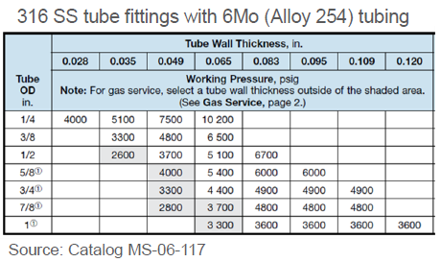
Manifolds

Who Would Benefit from Swagelok’s 6Moly Solutions
6Moly is a specially SS alloy that is particularly effective in the Oil & Gas market in offshore and near-shore applications and LNG facilities that experience a variety of technical challenges such as corrosion, high pressures and high temperatures.
As platform lifespans and asset utilization is becoming longer and longer, reliability and the overall cost of ownership become vital to the operation. 6Moly products can extend the life of your systems considerably compared to a regular 316 SS solution.

Introduction to Swagelok’s 6Moly Alloy – 6HN
Swagelok uses the higher nickel variant of 6Moly named 6HN. It is used to provide the ultimate in reliability and performance and offers enhanced corrosion protection and longer service life.

6HN material stands out due to its improved corrosion resistance (higher than 254 alloy).

Swagelok’s 6HN contains enhanced levels of chromium, molybdenum and nitrogen. This results in improved resistance to pitting and crevice corrosion in chloride-rich environments. The superaustenitic stainless steel alloy is designed to withstand extremely highly pressure, temperature and corrosive environments at a competitive price.

Recommended image option:
Material Selection Guide – pg 16)
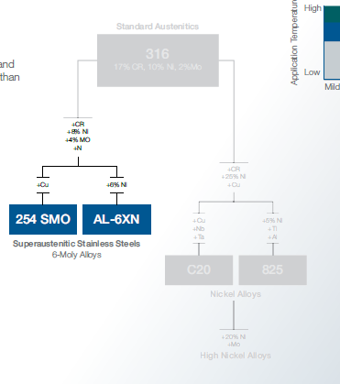

Recommended image option:
Selection criteria – what makes 6HN stand out?

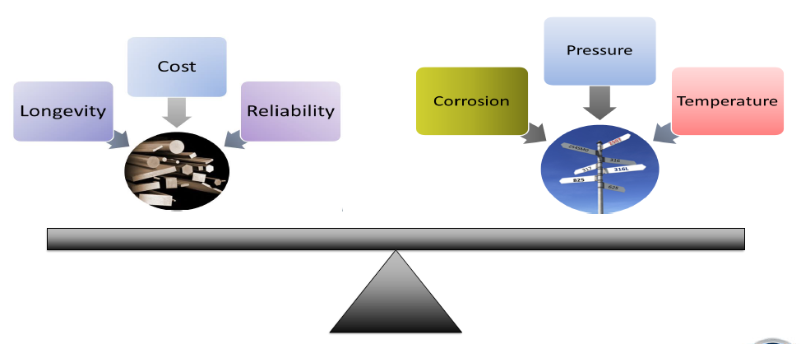

Benefits & Features
What sets 6HN apart?
Not all 6Mo alloys are created equal. Compared to 254, 6HN has 6% higher nickel (Ni) content, higher chromium (Cr) and lower copper (Cu).
This results in:

- Better corrosion resistance | - 6HN has higher levels of Cr than 254  - Crevice corrosion resistance well over 50°C (122°F)  - Less corrosion than 254 under crevice washers  - Lower Cu in 6HN results in less corrosion penetration
- More resistant to sigma phase formation

- Improved mechanical properties

- Higher ASTM temperature rating | Up to 700°F (371°C)  18.0 psi (1.24 bar)  (THIS TABLE NEED A LOT MORE WORK)
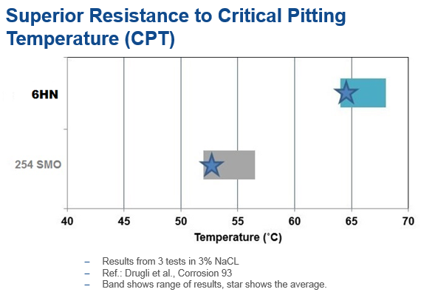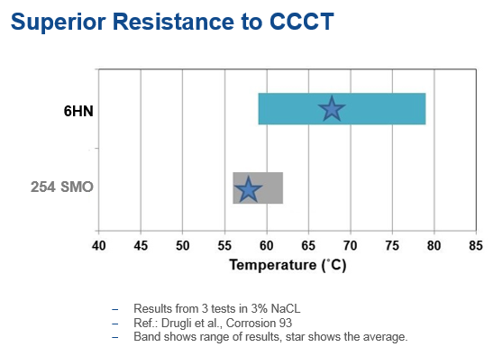
Recommended: Insert Norsok M-630 piping data standard – slide 5

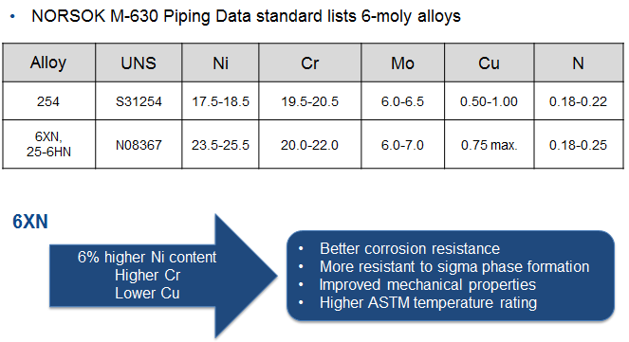

Other vital benefits include:
- Resistant to chloride pitting and crevice corrosion
- Resistant to CSCC
- 50% stronger than 300-series austenitic stainless steels
- Provides impact toughness, workability, and weldability
- Available with NACE MR0175 compliance
- Available with NORSOK-approved supply chain qualification standard M-650

Engineered Combinations
It is typically stainless steel tubing that is susceptible to pitting and crevice corrosion and not stainless steel fittings.
Fortunately, due to the superior hardness and performance during the swaging action, 316SS Swagelok tube fittings can be used in conjunction with 6Moly tubing.
This will help you realize significant material cost savings whilst offering a robust corrosion resistant solution. This is a fully validated and proven combination that is suitable a wider range of operating conditions.
Swagelok has conducted many different tests on this engineered combination of SS fittings with 6 Moly tubing including hydrostatic, tensile pull, gas seal, high temperature, low temperature, rotary flex and chloride stress corrosion cracking tests with no failures.

All of these Product Test Reports (PTR) are available on request – or on www.swagelok.com – and this engineered combination has been accepted by many International Oil Companies for construction projects and retrofits across the globe.

Table 1 below shows the approximate corrosion resistance performance of a range of alloys and table 2 shows you the further savings that can be enjoyed when using engineered combinations (6Moly tubing and SS Fittings).

Table 1, Average Price Points of different stainless steels compared to their ability to resist corrosion.
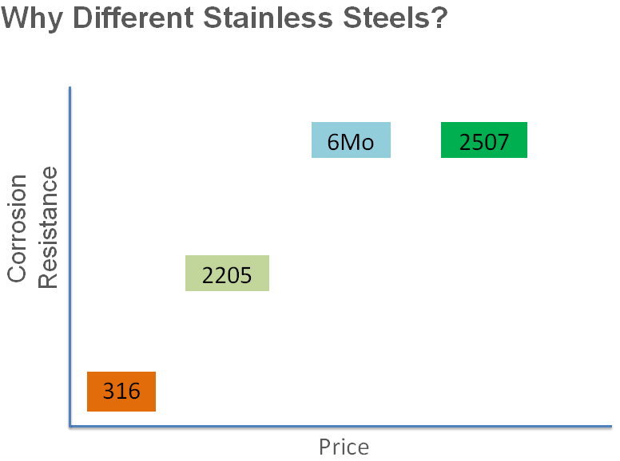

Table 2, Average Price Points of fitting and tubing combinations using different materials
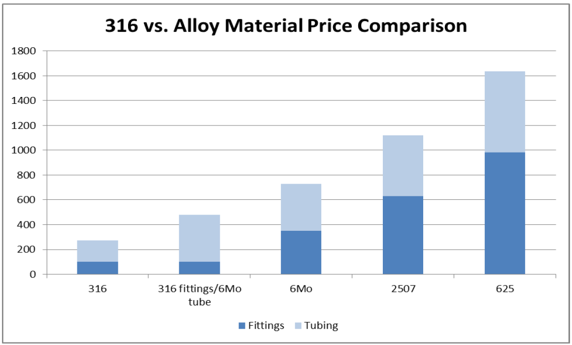

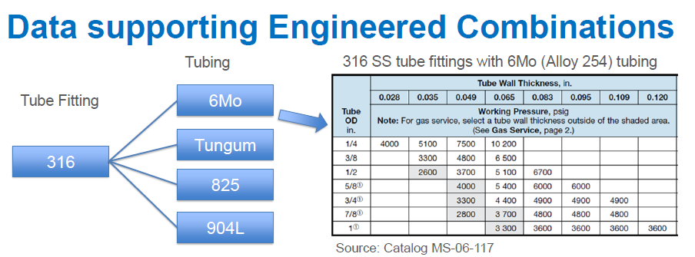

Why Swagelok?

Through our long history of industrial experience across a range of industries, Swagelok has been able to respond to the specific needs of the market with our full 6Moly offering.
And with the added advantage of the 6HN 6Moly alloy, Swagelok is able to provide a holistic and economically competitive product range, along with our usual engineering, operations and service support.

The quality of our products helps to ensure product and application longevity in corrosive environments and makes it easy for you to focus on other aspects of running your business.

Swagelok provides:

Reliability | - Optimal reliability - lower maintenance cost, minimized downtime  - Our distinct process controls provide reliable and quality products  - Our leak-tight design = less risk of costly accidents and media loss  - Advanced geo back ferrule for vibration resistance & tube grip  - Engineered combinations optimise cost and reliability
Product Availability | Global availability – when & where you need it
Full product basket | Full product line for a wide range of instrumentation & piping needs.  Products include fittings, valves and tubing
Robust Supply Chain | - Small and large orders are managed through flexible manufacturing and raw material  - Quick turn arounds provided for safety stocks on frequently used parts
Proven Swagelok tube fitting design | - SAT 12 process – no special tubing hardness required  - Our advanced geometry back ferrule provides vibration resistance and more direct tube gripping support
Technical Expertise
Onsite Services & Training
Custom Assemblies | (AGAIN TABLE NEED FINISHING)
Meets NACE MRO175 and NORSOK M-630s

