6Moly Application Case Study
Onshore LNG Terminal and Offshore Assets (SE Asia)

Construction Project Background

The project is comprised of two components – an offshore component and an onshore component.
The jobsite is located in a remote area in SE Asia in warm, tropical seas. The offshore project involves building two platforms complete with 13 new production wells. The onshore part involves the addition of an LNG train, LNG loading facility and supporting infrastructure.
Start-up is planned for mid-2020.
The expansion project will add an LNG liquefaction unit of 3.8 million tons per annum (MTPA) production capacity to the existing facility bringing total plant capacity to 11.4 MTPA.

Due to the warm, tropical environment, the International Oil Company (IOC) end user wanted the engineering design of the plants and platforms to include metallurgical solutions to protect against corrosion, in particular chloride induced stress corrosion cracking.
Two separate EPC packages were awarded – an offshore package awarded to a single contractor and an onshore package awarded to a Joint Venture (JV) of local and international engineering firms.
The EPC packages involved engineering, procurement, construction and installation.

Swagelok’s Proposed Solution

Swagelok, and the local Swagelok sales and service center, has worked with the IOC client for many years in this location (and globally). In 2012, Swagelok conducted an onsite audit and assessment of the steam system associated with the existing LNG trains.

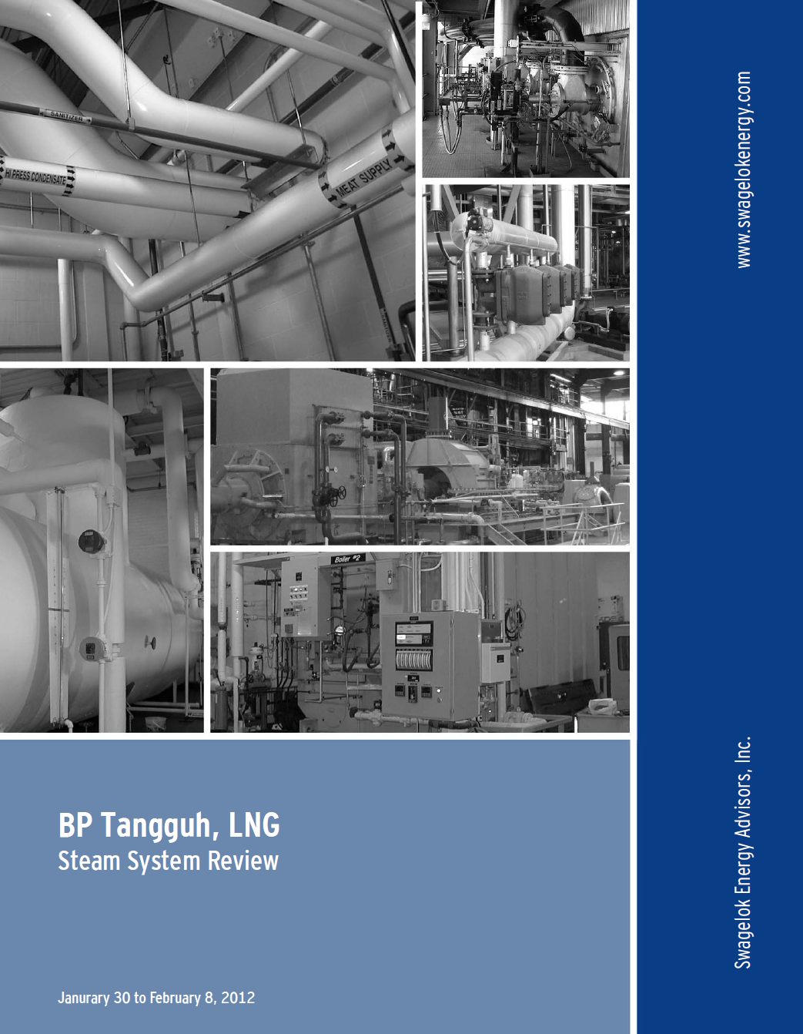

From that report, there was strong evidence of different types of corrosion at the facility – particularly along the tubing lengths, where they interfaced with tube supports and other structures as well as on pipe threads.
Later, during the design of the expansion project Swagelok worked with the pre-FEED engineering company and a 6Moly solution was proposed to dramatically reduce the corrosion.
In the end, following the FEED and Final Investment Decision the client decided to utilize a fully 6Moly solution of tubing and fittings for the onshore project whilst the offshore project featured an “Engineered Combination” of 6Moly tubing and SS fittings.
Typical Applications Featuring Swagelok 6Moly Products on the Project

Offshore
- Instrument hook up materials
- Hydraulic power units
- Chemical injection skids
- Well head control panels

Onshore
- General instrumentation hook up materials
- Grab sampling systems
- Condenser
- Flare package
- Fuel gas system and instrumentation
- Marine loading arm
- Nitrogen generator package
- Air cooled condenser
- Air dryer package
- Water treatment package
- Steam turbine generator
- Pump package

6Moly Engineered Combinations from Swagelok – Leverage the Benefits of a 6Moly Solution But With a Dramatically Reduced CAPEX

In the offshore portion of the project the client was looking for ways to reduce the upfront costs to try and keep to a reduced project budget.
However, they wanted to ensure that the systems that were built had some form of protection from chloride inducted stress corrosion cracking and other forms of crevice corrosion witnessed on the existing assets. It is typically stainless steel tubing that is susceptible to pitting and crevice corrosion and not the stainless steel fittings.

Fortunately, due to the superior hardness and performance during the swaging action, 316SS Swagelok tube fittings can be used in conjunction with 6Moly tubing.
This helped the client to realize significant material cost savings whilst offering a robust corrosion resistant solution. This was a fully validated and proven combination that is suitable a wider range of operating conditions.
Swagelok has conducted many different tests on this engineered combination of SS fittings with 6Moly tubing including hydrostatic, tensile pull, gas seal, high temperature, low temperature, rotary flex and chloride stress corrosion cracking tests with no failures.

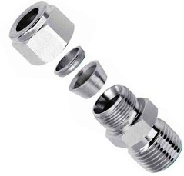

All of these Product Test Reports (PTR) are available on request – or on www.swagelok.com – and this Engineered Combination has been accepted by many International Oil Companies for construction projects and retrofits across the globe.

The table below shows the actual dollar spend for bulk materials of 6Moly tubing and SS fittings, valves, manifolds and other components for the two offshore platforms on this project.
The actual Engineered Combination spend was just under $2million.
We also modelled the comparative price of an all SS solution (approximately $1million) and a full 6Moly solution ($4million) for the exact same basket of products and real life quantities.
You can see the relative value of the Engineered Combination is much better than the fully 6Moly solution which was the main decision point for the client.

Other Swagelok Benefits

Swagelok, Swagelok Capital Projects Company – a wholly own subsidiary established by Swagelok to help manage large construction projects and the Swagelok sales and service network provided both EPC and IOC client a range of other project management and project optimization services.
The supply chain for the significant quantity of Swagelok products used on the project was managed globally through close coordination from manufacture to package vendor build and ultimately the job site.
A global project team – dedicated to the project – was established and technical support was provided at every stage of the project.
Bespoke Swagelok installation training was provided to package vendors and installation contractors to ensure integrity of the plant.
Locally configured stock – including significant quantities of 6Moly tubing - was deployed to the local jobsite serving Swagelok sales and service center.

